

**Oklahoma Christian University Student Search At-A-Glance**

**General Questions:**

1. What are your pain points, and what can we do to help solve them?
   1. Came out of September 150 applications behind
   2. CCCU/NACAP benchmarking. We don’t get enough applicants to acceptance stage. 63% applicants resolved. 68% at benchmarking schools.
2. Pretend I don’t know anything about the school. You have a minute to sell me on coming to the school.
   1. Not only do we focus on education outcomes, we have a unique blend of head and heart. Yes, we get good rates for job placement, but our stories impact the world for the better, and all for Christ. We are an urban city with plenty to do. That means you have access to practicums, internships and city access for life balance.
3. Funnel numbers and counselor numbers.
   1. 12 recruiters total (10 seniors).
   2. Current applications=2500; current matriculants=464-517.
   3. GOAL IS 520.

|  |  |
| --- | --- |
| **Area of Focus** | **Key Information** |
| Names not to exceed: | 75,000 (SR, JR, SO)  Will provide names using CMT. |
| Banner ad timing and execution | October 23, 2017  Will be directed to video provided in Basecamp. She needs to shorten a longer one and will post.  Run 30 Days |
| Banner ad sizes | 728x90  468x60  300x600  300x250  160x600 |
| Facebook and Instagram ad sizes | 300x250  500x262 |
| Contact for code on school website: | David Hardin  david.hardin@oc.edu |
| Our charge | * Senior search drive applications and campus visits * Historically have not done anything with early contact to students to juniors and 2nd semester sophomores * An interesting/dynamic fun marketing look and feel * No more big box look * Not married to being first, more married to being creative |
| Important to Director (the relationship) | * Want to learn from us * Been at one place, so wants best practice (never wants to be this is the way it’s always done) * Push me to be my best professional self (why are you…?) * Clear communication without feeling negative or sensitive about content or marketing changes |
| Post Card Size and Description | 10 x 5.5 inch on 130# cover stock.  Possible soft touch or high varnish, either way.  Mailed Pre-Sorted Standard Non-Profit |
| Seed Addresses  Personal email for purposes of banner ads |  |
| Are suspects loaded into CRM? | Load everyone—including suspects so will need a list of all unsubscribes at end of last email |
| Search Emails | Eight (4/2) |
| Distinctives | * Ethos of Christ informed education * Super residential campus * Harding and Abilene small town/small city * We have urban environment * We are about serious business—really solid outcomes, but not too serious, a bit information whimsical vibe about us * Approachable * Rowanda programs— * Church of Christ … OC has map of world on its heart * Speaker series interesting and challenging conversation and discourse |
| Landing Page Experience | Campus Visit Call to Action  High Energy with Movement |
| Nurture Emails and Scoring | * Must have application link in each * Under Jancy Scott * Humans of OC |
| Email Set-Up | * Comes from director’s address: jancy.scott@oc.edu * Bounce backs: admissions@oc.edu |
| Reports: | * Daily until the last email is sent. Then, every M/Th * Sent to Risa, Bonnie, Jancy, and Jennifer Jennifer.Weiss@oc.edu |
| New Client Dashboard Information: |  |
| Scoring: | * Visited Microsite: 10pts * Submitted from Microsite: 20pts * Clicked on a Link in Nurture emails: 20pts * Visited a page on client’s website (through ClickCapture): 5pts |
| Scheduled Monthly Meeting Preferences: |  |
| Invoice once or as installments? | Two installments |
| Sent W-9 | Sent 10.15.17 |

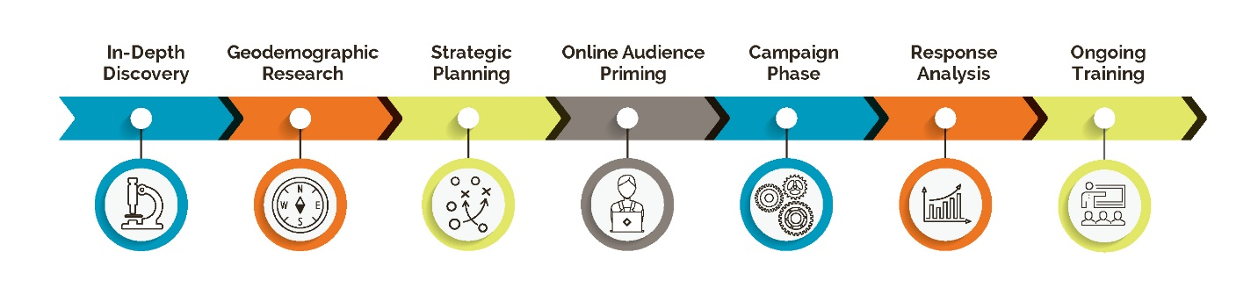

10.05.17 10.07.17 10.09.17 10.23.17